Practice Sheet
Chapter 8 (MySQL)

*Solutions are at the end of the document. SOLVE IT YOURSELF first. PLEASE NOTE, some questions may have several answers, the given solution is only 1 possible answer.

Consider the following Relational Schema:

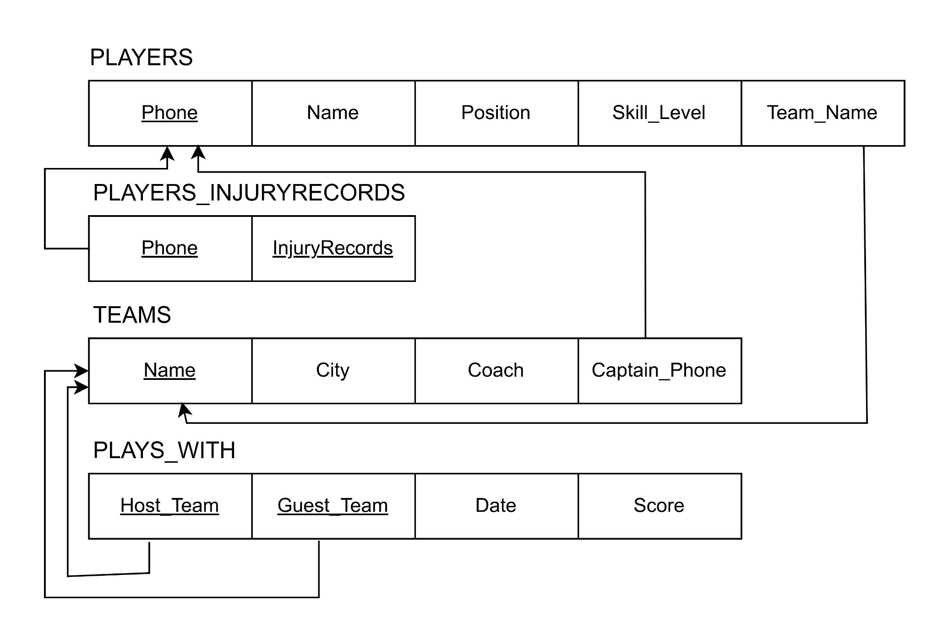
Guest_Score
Host_Score
GAMES

- Write appropriate SQL queries for the following questions. For each question write a single query.

  - Retrieve all information of all players where the team name has the term “City” in it or if the team name starts with an “A”.
  - Retrieve all information of the players who have the highest skill level.
  - Retrieve all information of the players who have the highest skill level for each Team.
  - Retrieve the average score of each host team. The average score should be printed as “host_average”.
  - Retrieve the list of cities all teams belong to. There should not be any duplicate cities in the output.
  - Retrieve the number of teams in each city sorted by city in alphabetical order.
  - Retrieve all game information where the guest team has a higher score than the host team in the year 2023.
  - Retrieve the maximum score of each guest team if the team has played as guest at least 3 times. The maximum score should be printed as “guest_max”.
  - Retrieve the Game information of the last 10 games.
  - Retrieve all game information for games played on the first recorded date. The information should be sorted by host team name.
  - Retrieve the information of players who play in the “center forward” position and whose skill level is higher than every single player who plays in the “center back” position.

- Write appropriate SQL queries for the following questions. For each question write a single query.

  - Retrieve all information for each team and the captain’s information of each team.
  - Retrieve the host team - name, city, score, guest team - name, city, score and game date of all games held in 2022.
  - Retrieve the Name, Position and Skill_Level of players who are members of a Host_Team and also have the highest skill level.
  - Retrieve the Team Name, Captain Name, Phone and Captain’s Injury Records of all Teams. The information should be sorted by the captain’s phone in ascending order.

SOLUTIONS:

Answer 1:

- Select * from Players where Team_Name Like “%City%” or Team_Name like “A%”;
- Select * from Players where Skill_Level = (Select max(Skill_Level) from Players);
- Select * from Players where (Team_Name, Skill_Level) in (Select Team_Name, max(Skill_Level) from Players group by Team_Name);
- Select Host_Team, Avg(Score) As Host_Average from Games group by Host_Team;
- Select Distinct City from Teams;
- Select City, count(*) from Teams group by City Order by City;
- Select * from Games where Guest_Score>Host_Score and Date Between “2023-01-01” and “2023-12-31”
- Select Guest_Team, max(Guest_Score) from Games group by Guest_Team having count(*)>=3;
- Select * from Games order by Date Desc Limit 10;
- Select * from Games where Date = (Select min(Date) from Games) order by Host_Team;
- Select * from Players where Position = “center forward” and Skill_level > all (Select Skill_Level from Players where Position = “center back”);

Answer 2:

- Select * from Teams T Inner Join Players P on T.Captain_Phone = P.Phone
- Select Host_Team, T1.City, Host_score, Guest_Team, T2.City, Guest_Score, Date from (Teams T1 Inner Join Games G on T1.Name = G.Host_Team) Inner Join Team T2 on T2.Name = G.Guest_Team) where Date Between “2022-01-01” and “2022-12-31”
- Select P.Name, Position, Skill_Level from Teams T, Players P, Games G where T.Name = P.Team_Name and T.Name = G.Host_Team and Skill_Level = (Select max(Skill_Level) from Players)
- Select T.Name, P.Name, P.Phone, injuryRecords from (Teams T inner join Players P on T.captain_phone = P.Phone) inner Join Players_injuryRecords PI on PI.Phone = P.Phone order by P.Phone

PRACTICE CHECKLIST:

SELECT
*
From
Where - condition clause, row wise
Or, And, Not/!
Between
Distinct
Is, In
Like, %, _
Order By, Asc, Desc
Limit
Lower, Upper, Year functions
Aggregate functions- min, max, sum, avg, count
Group By
Having - condition clause, group wise
Subqueries/nested queries
Any/All
Joins (Inner)

